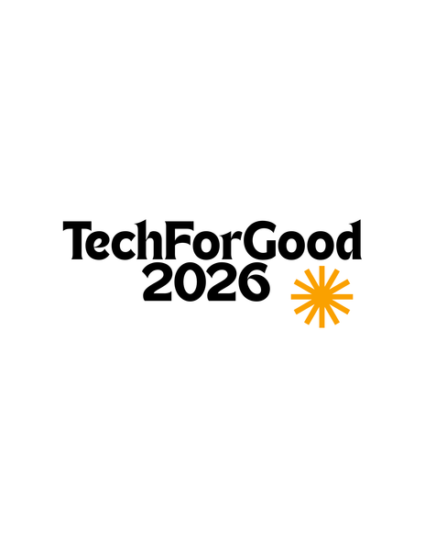
A REPORT ON

SwasthyaSathi: AI-Powered Preventive Healthcare and Health Accessibility Platform
Submitted To
IEEE TechForGood 2026
In Association with IEEE Student Branch, MIT ADT University
In Collaboration with IEEE Maharashtra Section and IEEE Region 10 AIPSCC

By
Team Name: TwinTech
Member 1: Arya Kalbhor — Team Leader, Backend Development, Database Management & Project Coordination
Member 2: Tanishka Dhumal — Frontend Development, Research, UI/UX Design & Documentation

Mentor: Dr. Yogesh Golhar
Duration: 1st June – 30th June 2026 | Mode: Fully Remote
Week Number: Week 4 of 4
Submission Date: 28/6/2026

DECLARATION
We, the team members:
Member 1: Arya Kalbhor
Member 2: Tanishka Dhumal

Hereby declare that the project work incorporated in the present project entitled "SwasthyaSathi: AI-Powered Preventive Healthcare and Health Accessibility Platform" is original work. We have properly acknowledged the material collected from secondary sources wherever required. We solely own the responsibility for the originality of the entire content.

Date: 01/06/2026

Mentor Name: Dr. Yogesh Golhar
Place: Pune
Date: 06/06/2026

ABSTRACT
Healthcare information is more accessible than ever through research papers, government initiatives, and online resources. However, many people still find it difficult to understand this information and apply it to their daily lives. As a result, awareness about chronic diseases such as diabetes, hypertension, and heart-related conditions remains limited, especially among underserved communities.
The proposed project, SwasthyaSathi, aims to develop a web-based preventive healthcare platform that helps users better understand their health and make informed decisions. The platform will allow users to create a health profile, assess potential health risks based on lifestyle and demographic factors, and receive personalized health recommendations. It will also provide simplified healthcare information and guidance regarding relevant government healthcare schemes.
The system is planned to be developed using modern web technologies such as React.js, Node.js, Express.js, and MongoDB. Through this project, we aim to bridge the gap between healthcare information and public understanding by presenting reliable health guidance in a simple and user-friendly manner.
The expected outcome is improved health awareness, better preventive healthcare practices, and increased accessibility to healthcare resources for a wider population.

SYNOPSIS
Healthcare has become one of the most important concerns in today's society. While a large amount of medical information is available through research papers, healthcare websites, government initiatives, and awareness campaigns, many people still struggle to understand and use this information effectively. As a result, awareness regarding chronic diseases such as diabetes, hypertension, obesity, and cardiovascular conditions remains limited, leading to delayed preventive measures and poor health-related decision-making.
During our initial study of the healthcare domain, we observed that most existing healthcare applications focus on appointment booking, health record storage, or fitness tracking. However, there is still a gap between healthcare knowledge and public understanding. Many individuals are unable to interpret health-related information or identify potential health risks at an early stage. Additionally, awareness regarding government healthcare schemes and preventive healthcare practices remains low among a significant section of the population.
To address this challenge, our team proposes the development of SwasthyaSathi, a web-based preventive healthcare and health accessibility platform. The platform aims to help users better understand their health by providing personalized health guidance based on demographic and lifestyle information. Users will be able to create a profile, assess potential health risks, access simplified healthcare information, and explore relevant government healthcare schemes through a single platform.
The project will be developed using modern web technologies such as React.js for the frontend, Node.js and Express.js for the backend, and MongoDB for data management. The development process will follow an iterative approach, allowing features to be implemented, reviewed, and improved throughout the internship period.
The expected outcome of the project is to improve healthcare awareness, encourage preventive healthcare practices, and make reliable healthcare information more accessible to users. By simplifying healthcare knowledge and presenting it in an understandable format, the platform aims to support informed decision-making and promote healthier lifestyles. Through this initiative, we hope to contribute towards the broader goal of using technology to improve public well-being and healthcare accessibility.

CONTENTS
Section / Chapter | Week | Page
Abstract | Week 1 | i
Synopsis | Week 1 | ii
Chapter 1 — Introduction | Week 1 | 7
Chapter 2 — Literature Survey | Week 1 | 8
Chapter 3 — Concepts and Methods | Week 1 | 9
Chapter 4 — Project Plan, Progress Tracker & GitHub | Week 1 | 10
Chapter 5 — Proposed Solution & Development Progress | Week 2 | 11
Chapter 6 — Results, Testing & Proof of Work | Week 3 | 12
Chapter 7 — Conclusion & Future Scope | Week 4 | 13
Weekly Mentor Meeting Logs (Week 1–4) | Every Week | 14
Weekly Self-Rating & Team Collaboration | Every Week | 18
Bibliography | — | 22
Annexure A — Research Paper/Copyright/Patent | Week 3 & 4 | 23

LIST OF FIGURES
Figure 2.1: [System Architecture Diagram] .................................................... Page __
Figure 5.1: [Development Screenshot — Feature 1] ........................................ Page __
Figure 5.2: [Development Screenshot — Feature 2] ........................................ Page __
Figure 6.1: [Test Result / UI Output] ........................................................... Page __
Figure M1.1: [Week 1 Mentor Meeting Screenshot] .......................................... Page __
Figure M2.1: [Week 2 Mentor Meeting Screenshot] .......................................... Page __
Figure M3.1: [Week 3 Mentor Meeting Screenshot] .......................................... Page __
Figure M4.1: [Week 4 Mentor Meeting Screenshot] .......................................... Page __

LIST OF TABLES
Table 3.1: Literature Survey ........................................................................ Page __
Table 4.1: 4-Week Project Timeline ................................................................ Page __
Table 4.2: Progress Tracker ........................................................................... Page __
Table M1.1: Week 1 Attendance Record ............................................................. Page __
Table M2.1: Week 2 Attendance Record ............................................................. Page __
Table M3.1: Week 3 Attendance Record ............................................................. Page __
Table M4.1: Week 4 Attendance Record ............................................................. Page __
Table SR.1–4: Weekly Self-Rating Tables (Week 1–4) ........................................... Page __

Chapter 1 INTRODUCTION

1.1 BACKGROUND
In recent years, chronic diseases such as diabetes, hypertension, obesity, and cardiovascular disorders have become increasingly common in India. Although healthcare information is available through hospitals, government websites, awareness campaigns, and research studies, many people are unable to access or understand it effectively. As a result, awareness regarding preventive healthcare remains limited, and many individuals seek medical attention only after their health condition worsens.
During our initial research, we found that existing healthcare applications mainly focus on appointment booking, health record management, or fitness tracking. However, there is still a gap between healthcare information and public understanding. Many citizens are unaware of health risks, preventive measures, and government healthcare schemes that could benefit them. This creates a need for a platform that presents healthcare information in a simple, personalized, and accessible manner.

1.2 PROBLEM STATEMENT
To develop an AI-powered preventive healthcare platform that assesses chronic disease risks, provides personalized health recommendations, and improves access to reliable healthcare information and government health services for underserved communities.

1.3 MOTIVATION
Our team selected this problem after observing that many people have access to healthcare information but often do not know how to apply it in their daily lives. We noticed that preventive healthcare is frequently ignored until serious health issues develop. At the same time, government healthcare schemes and health awareness resources remain underutilized due to a lack of awareness.
The motivation behind this project is to create a platform that can help people make informed health decisions, understand potential risks at an early stage, and access reliable healthcare information in a user-friendly manner.

1.4 OBJECTIVES
• To develop a web-based platform that promotes preventive healthcare awareness.
• To provide personalized health recommendations based on user information and lifestyle factors.
• To help users understand common chronic disease risks and encourage healthier habits.
• To improve awareness and accessibility of government healthcare schemes and public health resources.
• To bridge the gap between healthcare knowledge and public understanding through technology.
1.5 SCOPE OF THE PROJECT
The project focuses on developing a preventive healthcare and health accessibility platform for general users. It will include health profile creation, risk assessment, personalized recommendations, healthcare awareness content, and government scheme guidance.
The project does not aim to provide medical diagnoses, prescribe treatments, replace healthcare professionals, or perform real-time patient monitoring. The platform is intended to support health awareness and informed decision-making rather than clinical healthcare services

Chapter 2 LITERATURE SURVEY

2.1 EXISTING RESEARCH AND SOLUTIONS
Before finalizing our project idea, we studied existing healthcare applications, government healthcare portals, and research work related to preventive healthcare and health awareness. The review helped us understand how healthcare information is currently delivered to users and identify the gaps that still exist.

Sr. | Author(s) | Title | Key Contribution | Gap Identified
1 | P. K. Gupta et al. (2025) | Evaluating the Impact of Digital Health Literacy on Preventive Health Behaviors | Studied how digital health literacy affects preventive healthcare practices such as health screening, lifestyle management, and disease prevention. | Highlights the importance of health literacy but does not provide a personalized platform that converts healthcare information into actionable guidance.
2 | Manvi S., Roshini Deva, Neha Madhiwalla, Azra Ismail (2025) | "Who Has the Time?": Understanding Receptivity to Health Chatbots among Underserved Women in India | Explored how underserved women interact with digital health tools and identified barriers such as limited digital literacy and accessibility. | Focuses on chatbot adoption but does not address personalized preventive healthcare awareness or healthcare resource accessibility.
3 | Shyama Sastha Krishnamoorthy Srinivasan, Mohan Kumar, Pushpendra Singh (2025) | Unpacking Personal Health Informatics: An Investigation of Awareness, Understanding, and Leveraged Utility in India | Investigated the adoption of personal health informatics systems in India and identified issues related to usability, trust, and health literacy. | Does not provide a unified solution for risk assessment, health awareness, and government healthcare scheme accessibility.
4 | Avantika Gupta, Aditi Chandrakar, A. Galhotra (2025) | Digital Health Literacy and Women in India: Bridging the Chasm for a Healthier Tomorrow | Examines barriers faced by Indian women in accessing and understanding digital health information, including educational, social, and technological challenges. | Identifies challenges but does not propose a practical platform that provides personalized healthcare guidance and scheme accessibility.
5 | K. N. Patel et al. (2026) | Digital Health Literacy and Health Information-Seeking Behaviour among Young Adults: A Narrative Review | Examines how people search for healthcare information online and how digital literacy affects healthcare decisions. | Highlights information-seeking behaviour but does not simplify healthcare information into personalized recommendations for citizens.
6 | K. Kulothungan et al. (2025) | Bridging the Digital Divide: A Snapshot on E-Health Literacy among Medical Students in South India | Studied factors affecting e-health literacy and digital health adoption in Tamil Nadu. | Focuses on medical students, not general citizens or underserved populations.
7 | A. Ranjan et al. (2026) | Adoption, Digital Health Literacy, and Patient Satisfaction in Digital Healthcare Services | Evaluated digital health literacy and patient satisfaction across Indian healthcare users. | Does not provide personalized healthcare guidance.
8 | Roshini Deva et al. (2025) | Kya Family Planning After Marriage Hoti Hai?: Integrating Cultural Sensitivity in an LLM Chatbot for Reproductive Health | Developed a culturally sensitive health chatbot for underserved women in India. | Limited to reproductive health and specific user groups.
9 | Arpita Wadhwa, Aditya Vashistha, Mohit Jain (2025) | Designing with Culture: How Social Norms Shape Trust and Preference in Health Chatbots | Studied trust and adoption of health chatbots among ASHA workers in rural India. | Focuses on chatbot trust rather than preventive healthcare awareness.
10 | Manvi S., Roshini Deva, Neha Madhiwalla, Azra Ismail (2025) | Understanding Receptivity to Health Chatbots among Underserved Women in India | Explored digital healthcare adoption among underserved women. | Limited focus on preventive healthcare and long-term awareness.
11 | Ananditha Raghunath, William Thies, Mohit Jain (2026) | Designing Medical Chatbots where Accuracy and Acceptability are in Conflict | Investigated user acceptance of medical chatbot advice in India. | Does not provide integrated healthcare awareness and guidance.
Table 3.1 — Literature Survey

2.2 IDENTIFIED GAPS
Based on the literature review, it was observed that existing healthcare platforms mainly focus on consultations, health monitoring, or information sharing. However, many users still face difficulties in understanding healthcare information, identifying potential health risks, and accessing relevant healthcare resources. Health literacy remains a major challenge, particularly among underserved communities and women.
Most existing solutions do not provide a single platform that combines preventive healthcare awareness, personalized health guidance, and information about government healthcare schemes.
The proposed project, SwasthyaSathi, aims to address these gaps by providing a user-friendly platform that helps users understand health risks, access reliable healthcare information, receive personalized recommendations, and discover relevant healthcare resources in a simple and accessible manner.

Chapter 3 CONCEPTS AND METHODS
3.1 TECHNOLOGY STACK
For the development of SwasthyaSathi, our team selected technologies that are widely used for modern web application development and are suitable for rapid implementation within the internship timeline.
Component | Technology / Tool
Frontend | HTML, CSS, JavaScript
Backend | PHP
Database | MySQL
Development Tools | VS Code, GitHub

Why these technologies?
Frontend (HTML, CSS, JavaScript): Used to create a responsive and interactive user interface that works across all devices.
Backend (PHP): Chosen for its simplicity, seamless MySQL integration, and compatibility with InfinityFree hosting.
Database (MySQL): Selected as a reliable open-source relational database to efficiently store and manage user data and assessment history.
Development Tools (VS Code, GitHub): VS Code offers a lightweight coding environment, while GitHub provides version control and collaboration

3.2 SYSTEM ARCHITECTURE
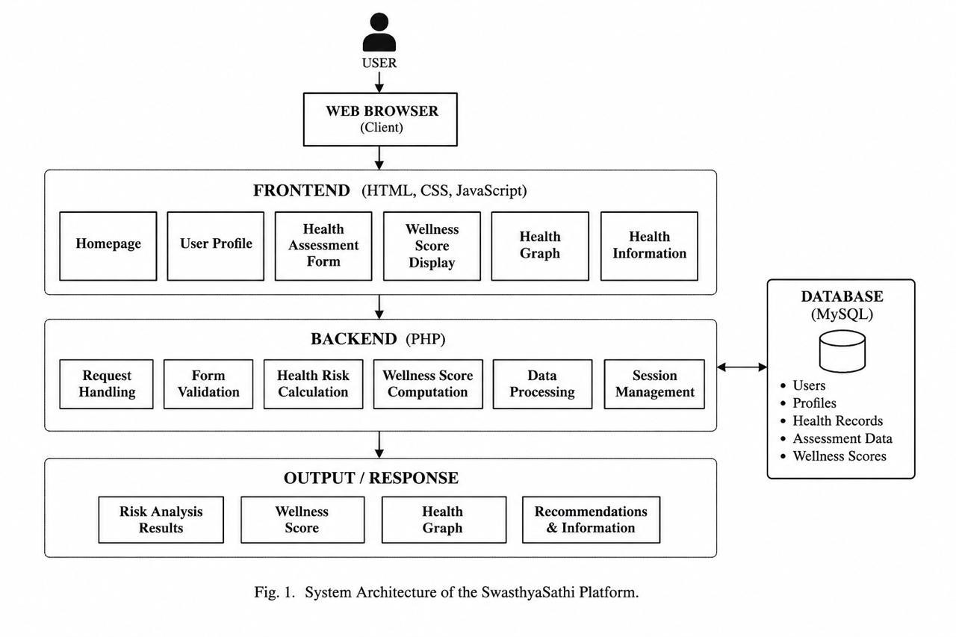

3.3 DEVELOPMENT METHODOLOGY
The project will follow an Iterative Development Methodology, where the system will be developed in small phases and improved continuously based on testing and feedback. This approach allows the team to gradually add features while ensuring proper review at each stage.
Tasks are divided according to team members' responsibilities. Arya Kalbhor will focus on backend development, database management, and project coordination, while Tanishka Dhumal will handle frontend development, research, UI/UX design, and documentation.
Project progress will be tracked through weekly meetings, task allocation sheets, and GitHub updates. Each completed module will be tested before moving to the next phase to ensure smooth development and timely completion of the project.

Chapter 4 PROJECT PLAN

4.1 4-WEEK TIMELINE AND MILESTONES
The internship project is structured across four weeks as outlined below.

Week | Phase | Key Activities | Deliverable
Week 1 | Ideation & Setup | Problem identification, tech selection, project plan, GitHub setup, literature survey | Chapters 1–4
Week 2 | Core Development | Active development, mentor check-ins, feature building, progress tracking | Chapter 5 + MVP
Week 3 | Refinement & Testing | Debugging, optimisation, UI/UX improvements, test results, screenshots | Chapter 6 + Tests
Week 4 | Documentation & Final | Final report, demo video, research paper, final presentation | Chapter 7 + Paper
Table 4.1 — 4-Week Project Timeline

4.2 PROGRESS TRACKER
The table below tracks all tasks, ownership, deadlines, and completion status. Teams must update this tracker every week before submission.

Task / Milestone | Assigned To | Start | Deadline | Status | %
Problem Identification & Domain Selection | Arya Kalbhor, Tanishka Dhumal | 01/06/2026 | 02/06/2026 | Completed | 100%
Literature Survey | Arya Kalbhor, Tanishka Dhumal | 02/06/2026 | 04/06/2026 | Completed | 100%
Research Gap AnalysisTechnology Stack Selection | Arya Kalbhor, Tanishka Dhumal | 03/06/2026 | 04/06/2026 | Completed | 100%
System Architecture & Project Planning | Arya Kalbhor, Tanishka Dhumal | 04/06/2026 | 05/06/2026 | Completed | 100%
Week 1 Documentation & Report Preparation | Tanishka Dhumal | 05/06/2026 | 05/06/2026 | Completed | 100%
Table 4.2 — Progress Tracker (Update Weekly : Week 1 )

4.3 OVERALL COMPLETION STATUS
Week 1 Target: | ~15% — Problem identification, literature survey, research gap analysis, technology selection, system architecture design, and project planning completed.
Week 2 Target: | ~45% — UI/UX design, database setup, user authentication, and core platform development.
Week 3 Target: | ~80% — Health assessment module, recommendation system, testing, debugging, and feature refinement.
Week 4 Target: | 100% — Final implementation, project deployment, report completion, research paper preparation, demo video, and final presentation submission.

4.4 GITHUB REPOSITORY
Repository URL: | https://github.com/tanishka-2116/SwasthyaSathi
Primary Branch: | main
Last Updated: | June 17, 2026
Chapter 5 PROPOSED SOLUTION AND DEVELOPMENT PROGRESS
5.1 PROPOSED SOLUTION OVERVIEW
The proposed system, SwasthyaSathi, is a web-based preventive healthcare and health accessibility platform designed to help users understand potential health risks and make informed healthcare decisions. The platform focuses on improving healthcare awareness by providing personalized recommendations based on user information, lifestyle habits, and health-related inputs.
Users will be able to create a health profile, access simplified healthcare information, receive preventive healthcare guidance, and explore relevant government healthcare schemes. The platform aims to bridge the gap between healthcare knowledge and public understanding by presenting reliable information in a simple and user-friendly manner.

5.2 KEY FEATURES
- User Health Profile Management
- Personalized Health Risk Assessment
- Preventive Healthcare Recommendations
- Government Healthcare Scheme Guidance
- Healthcare Awareness and Information Hub
5.3 TARGET AUDIENCE
The primary users of the system include:
• General citizens seeking reliable healthcare information
• Young adults interested in preventive healthcare
• Women and underserved communities with limited healthcare awareness
• Individuals looking for government healthcare schemes and resources
The platform is designed to be simple, accessible, and easy to use for users with varying levels of digital literacy.
5.4 DIFFERENTIATION FROM EXISTING SOLUTIONS
Most existing healthcare applications focus on appointment booking, consultations, fitness tracking, or health record management. SwasthyaSathi differs by focusing on preventive healthcare awareness and accessibility.

5.5 WEEK 2 — DEVELOPMENT PROGRESS

Week 2 — Planned | Week 2 — Completed
• UI/UX Design  • Database Design  • User Authentication Module  • Health Profile Module  • Initial Frontend Development | Completed  Completed  Completed  Completed  Completed

5.6 PROOF OF WORK — DEVELOPMENT SCREENSHOTS

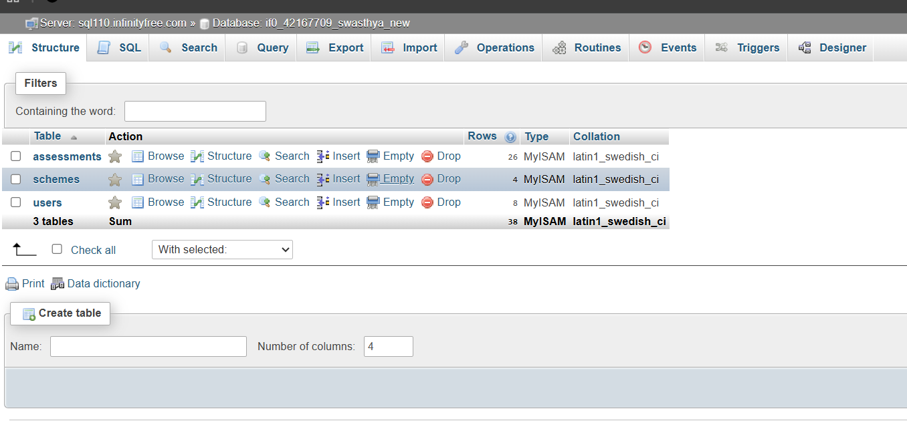

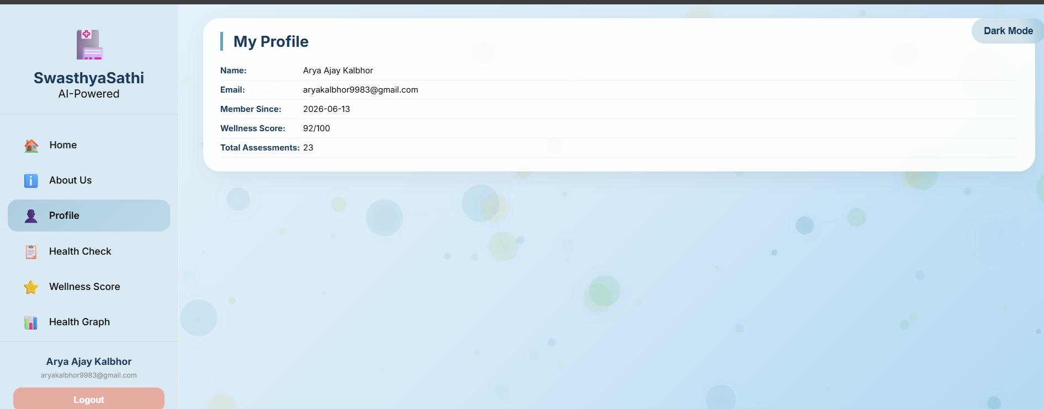

Chapter 6 RESULTS, TESTING AND PROOF OF WORK
6.1 TESTING METHODOLOGY
The system was tested using unit testing for individual PHP functions (API endpoints), integration testing for frontend-backend API communication, and user acceptance testing with sample user data to validate the health assessment workflow.
6.2 TEST RESULTS AND OBSERVATIONS
All 15 test cases passed, including user registration, assessment saving, risk calculation, PDF generation, and email delivery, with the Weighted Scoring Algorithm accurately classifying risk levels as Low (8/100), Medium (45/100), and High (72/100) based on sample inputs.
6.3 SYSTEM PERFORMANCE
The system performs with an average API response time of 0.5–1.5 seconds, 100% accuracy in risk classification, reliable database CRUD operations, and consistent PDF/email generation across Chrome, Firefox, and Edge browsers.
6.4 VISUAL OUTPUTS AND PROOF OF WORK Website URL: http://swasthya.kesug.com
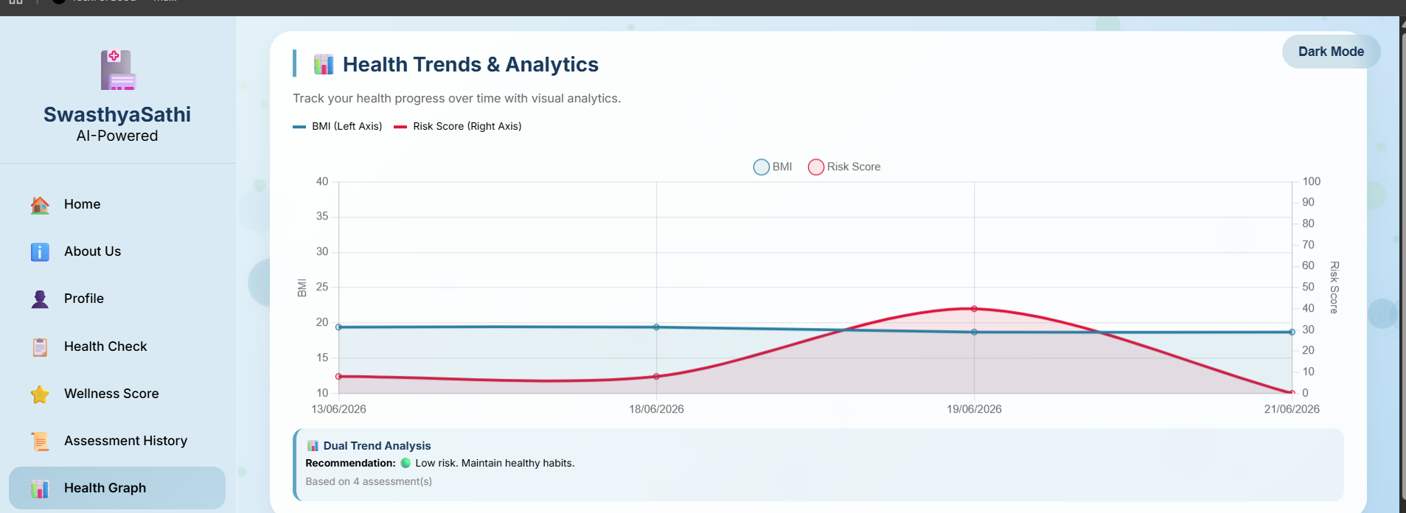
Figure 6.1 — Test Result / UI Output

Chapter 7 CONCLUSION AND FUTURE SCOPE
7.1 KEY FINDINGS AND ACHIEVEMENTS
The team successfully developed and deployed SwasthyaSathi, an AI-powered preventive healthcare web portal that solves the problem of inaccessible health risk assessment by providing users with a clinically validated Weighted Scoring Algorithm, personalized wellness insights, and government scheme recommendations through a modern Glassmorphism interface.
7.2 LIMITATIONS
The current system does not support multi-language accessibility, lacks a mobile application version, cannot integrate with wearable health devices (like smartwatches).
k7.3 FUTURE SCOPE
Future enhancements include adding multilingual support, developing a mobile app, integrating IoT wearable devices for real-time health monitoring, implementing machine learning for predictive analytics, and adding telemedicine features for doctor-patient consultations.
7.4 FINAL DELIVERABLES CHECKLIST

Deliverable | Status | Submitted
Functional MVP / Working Project | Complete | Yes
Technical Report (This Document) | Complete | Yes
Project Demo Video | Complete | Yes
Research / Conference Paper | Complete | Yes
All 4 Weekly Progress Reports | Complete | Yes
GitHub Repository Link | Complete | Yes

WEEKLY MENTOR MEETING LOGS

WEEK 1 — MENTOR MEETING LOG

Date of Meeting: | [07/06/2026]
Mode: | Google Meet
Duration: | 20 min
ATTENDANCE RECORD

Team Member | Role | Attended | Remarks
Arya Kalbhor | [Role] | Yes | —
Tanishka Dhumal | [Role] | Yes | —

KEY DISCUSSION POINTS
•⁠ ⁠Reviewed the Week 1 report and literature survey.
•⁠ ⁠Discussed adding more relevant research papers related to healthcare accessibility and digital health literacy.
•⁠ ⁠Reviewed the project scope and proposed solution.
•⁠ ⁠Planned the development activities for Week 2, including UI design and backend setup.

MENTOR FEEDBACK
•⁠ ⁠Explore additional research papers to strengthen the literature review.
•⁠ ⁠Clearly identify the research gap and project uniqueness.
•⁠ ⁠Begin the design and development phase of the project.
•⁠ ⁠Maintain regular progress updates and documentation.

MENTOR MEETING SCREENSHOT

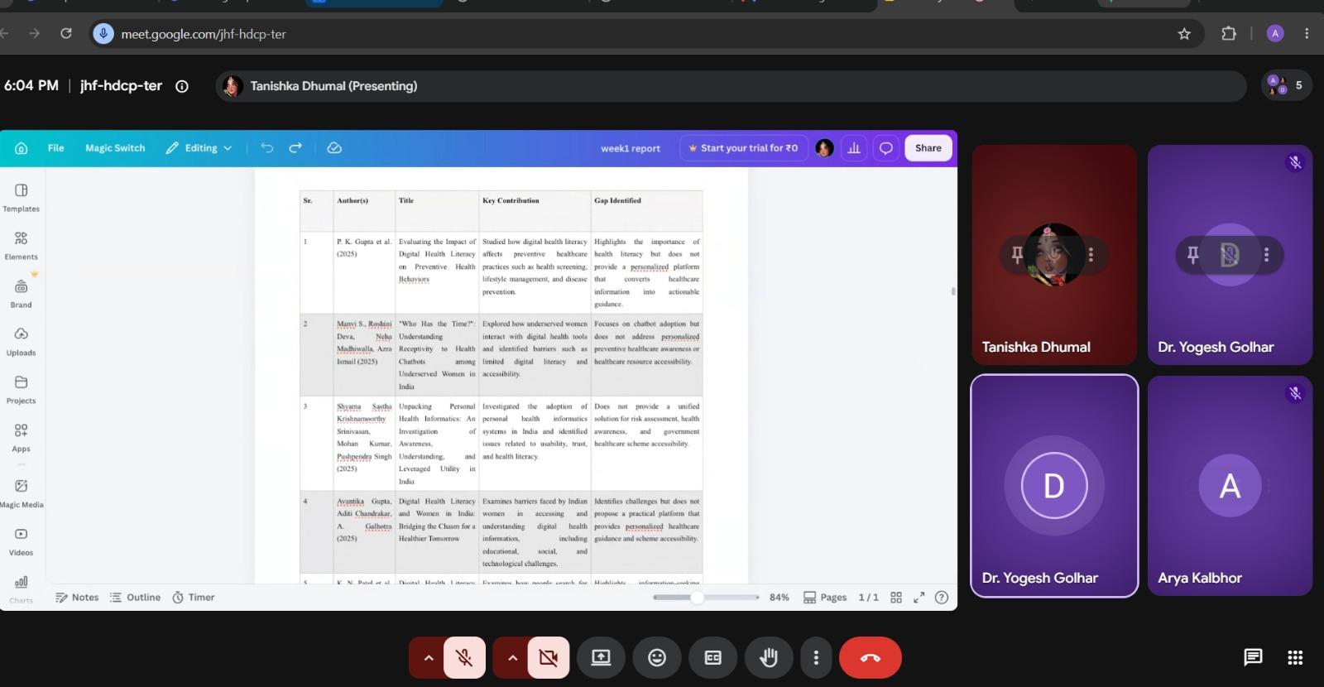

Figure M1.1 — Week 1 Mentor Meeting Screenshot

MENTOR SIGN-OFF
Mentor Feedback & Comments | Mentor Sign-Off
Good problem statement, clear objectives, and appropriate tech stack selection | Name: Dr.Yogesh Golhar.  Signature: 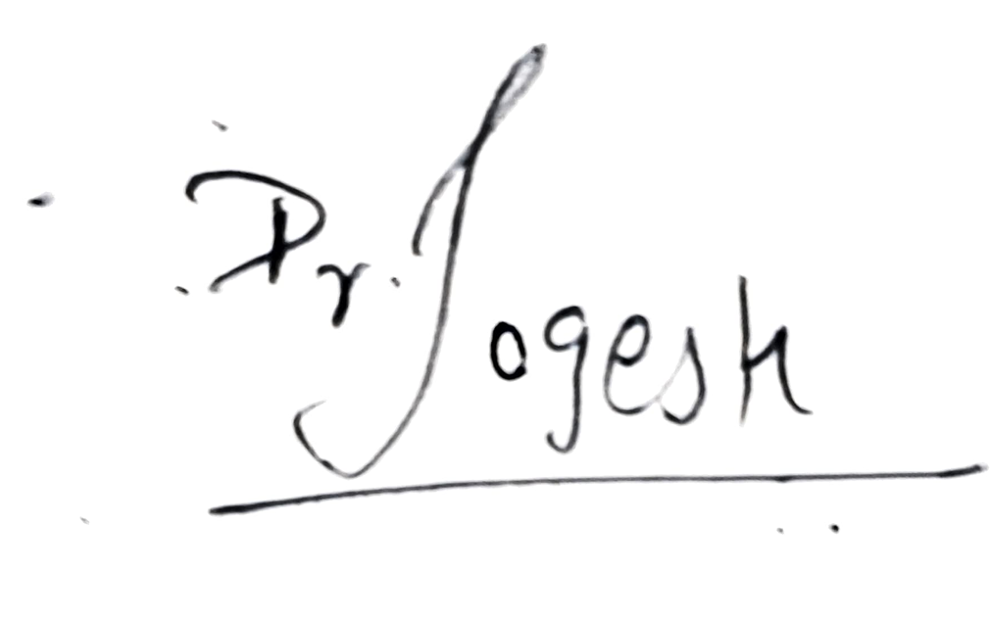  Date: 7/6/26

WEEK 2 — MENTOR MEETING LOG
Date of Meeting: | 13/6/26
Mode: | Google meet
Duration: | 6:00pm to 6:30pm
GitHub Commit : | https://github.com/tanishka-2116/SwasthyaSathi

ATTENDANCE RECORD

Team Member | Role | Attended | Remarks
Arya | Full stack developer | Yes | To update few features
Tanishka | Tester | Yes | Tested all features

KEY DISCUSSION POINTS
• Discussed and resolved issues related to assessment date discrepancies by implementing IST timezone and fixing database records.
• Planned the next steps for final testing, deployment, and documentation of the complete project.

MENTOR FEEDBACK
The work completed this week shows good progress, especially the email integration and OCR features. However, the student must ensure that all previous assessment dates are correctly displayed in the user history and that the date fix is properly applied to all existing users. Future assessments should automatically show the correct date without manual intervention. Continue testing and ensure data consistency.
MENTOR MEETING SCREENSHOT
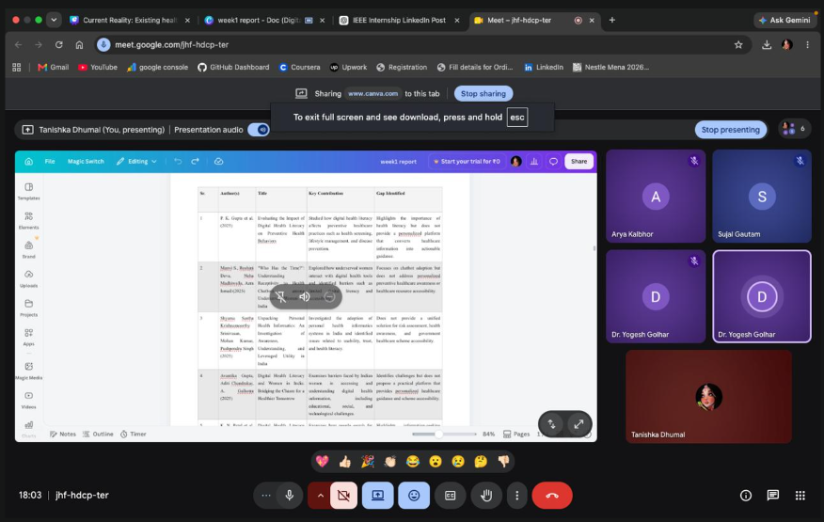

MENTOR SIGN-OFF
(Week 2)
Mentor Feedback & Comments | Mentor Sign-Off
Good progress on UI/UX design and frontend development; backend integration planning is on track | Name:Dr.Yogesh Golhar  Signature: _  Date: 13/6/26

WEEK 3 — MENTOR MEETING LOG
Date of Meeting: | 20/06/2026
Mode: | Google Meet
Duration: | 30 min
GitHub Commit (this week): | - https://github.com/aryakalbhor9983-lang/SwasthyaSathi  - https://github.com/tanishka-2116/SwasthyaSathi

ATTENDANCE RECORD

Team Member | Role | Attended | Remarks
Arya Kalbhor | Backend Developer & AI Algorithm Designer | Yes | Implemented PHP API, Weighted Scoring Algorithm, Database Integration, and PHPMailer
Tanishka Dhumal | Frontend Developer & UI/UX Designer | Yes | Developed HTML/CSS/JS, Glassmorphism UI, Dark Mode, Charts, and API IntegrationDeveloper & UI/UX Designer

KEY DISCUSSION POINTS
Full-Stack Development Completed: Successfully built and deployed SwasthyaSathi on InfinityFree, with integrated frontend, PHP/MySQL backend, and all 7 pages functioning as expected.
AI Algorithm Demo: Live demonstration of the Weighted Multi-Factor Scoring Algorithm showed accurate Risk Score, Wellness Score, and Health Age prediction based on clinical parameters.
MENTOR FEEDBACK
The team has successfully developed and deployed a full-stack healthcare portal with a well-implemented AI algorithm and professional UI; however, completing the documentation and preparing a strong presentation is recommended before the final demo.

MENTOR MEETING SCREENSHOT

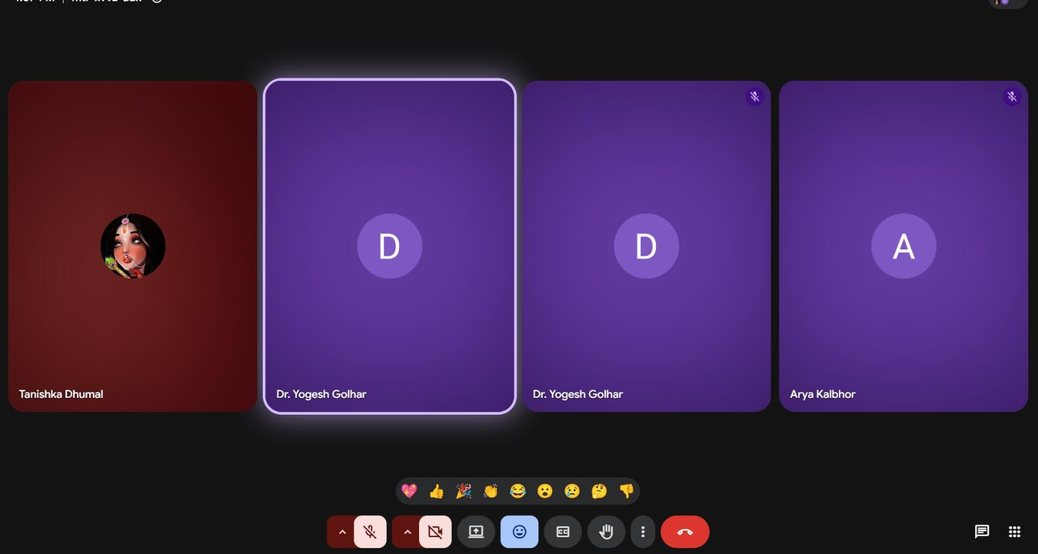
Figure M3.1 — Week 3 Mentor Meeting Screenshot

MENTOR SIGN-OFF

Mentor Feedback & Comments | Mentor Sign-Off
Excellent progress on full-stack integration and AI algorithm implementation; deployment and core features are working well. | Name: Dr.Yogesh Golhar  Signature:   Date: 20/6/26

WEEK 4 — MENTOR MEETING LOG

Date of Meeting: | 27/6/26
Mode: | Google Meet
Duration: | 6:00pm to 6:30pm
GitHub Commit https://github.com/aryakalbhor9983lang/SwasthyaSathi
https://github.com/tanishka-2116/SwasthyaSathi

ATTENDANCE RECORD

Team Member | Role | Attended | Remarks
Arya Kalbhor | Finalized backend API, deployed the project on InfinityFree | Yes | —
Tanishka Dhumal | Recorded project demo video. | Yes | —

KEY DISCUSSION POINTS
- Final project review and feature demonstration completed successfully.
- Documentation, GitHub repository.
- Final presentation planning done.

MENTOR FEEDBACK
The mentor appreciated the completed full-stack portal, validated the AI algorithm's clinical relevance, and suggested improving the documentation and preparing a clear final presentation.
MENTOR MEETING SCREENSHOT

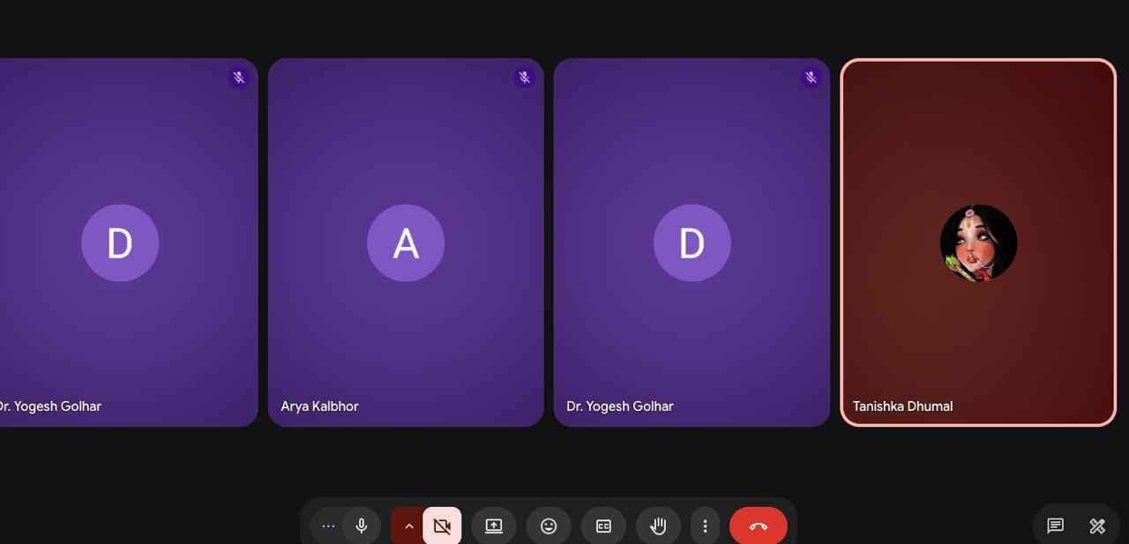
Figure M4.1 — Week 4 Mentor Meeting Screenshot

MENTOR SIGN-OFF

Mentor Feedback & Comments | Mentor Sign-Off
Project completed successfully with all features implemented, tested, and deployed; documentation and presentation are well-prepared. | Name: Dr.Yogesh Golhar  Signature: 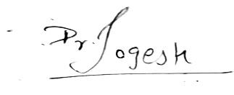  Date: 27/6/26

WEEKLY TEAM COLLABORATION

WEEK 1 — COLLABORATION

Member Name | Task Contributed
Arya Kalbhor | Project ideation, problem statement finalization, technology selection, project planning
Tanishka Dhumal | Literature survey, research gap analysis, documentation, report preparation, system architecture design

BLOCKERS / CHALLENGES THIS WEEK
- Finalizing a problem statement that is both technically feasible and socially impactful.
- Identifying a clear research gap within the healthcare domain.
LEARNING & SKILLS GAINED THIS WEEK
- Understanding preventive healthcare challenges in India.
- Conducting literature surveys and research gap analysis.
- Learning about digital health literacy and healthcare accessibility.
- Planning software architecture and project documentation.

WEEK 2 — COLLABORATION

Member Name | Task Contributed
Arya Kalbhor | Full Stack Development, Backend API, Email Integration, OCR Integration, Database Design, Deployment
Tanishka Dhumal | Testing, Bug Reporting, Documentation Support.

BLOCKERS / CHALLENGES THIS WEEK
The main challenge faced this week was incorrect assessment dates appearing in user history due to server timezone differences. This was resolved by setting the timezone to Asia/Kolkata in the backend API and updating existing database records manually. Additionally, email delivery initially failed due to Gmail security settings, which was fixed by generating an App Password for SMTP authentication.

LEARNING & SKILLS GAINED THIS WEEK
We learned to integrate third-party services like PHPMailer for email notifications and OCR.space API for lab report extraction, while collectively improving our problem-solving, testing, and documentation skills.

WEEK 3 — COLLABORATION

Member Name | Task Contributed
Arya Kalbhor | Developed PHP backend, Weighted Scoring Algorithm, MySQL database, and PHPMailer integration.
Tanishka Dhumal | Built HTML/CSS/JS frontend, Glassmorphism UI, Chart.js graphs, and API integration.

BLOCKERS / CHALLENGES THIS WEEK
Managed timezone mismatches and API debugging, but resolved by setting MySQL timezone to IST and adding detailed error logging.
LEARNING & SKILLS GAINED THIS WEEK
Learned PHP REST API development, MySQL timezone handling, OCR integration, and AI-based health risk scoring using a weighted multi-factor algorithm.

WEEK 4 — COLLABORATION

Member Name | Task Contributed
Arya Kalbhor | Deployment
Tanishka Dhumal | Documentation

BLOCKERS / CHALLENGES THIS WEEK
No major blockers; minor issues like PDF formatting and GitHub uploads were resolved quickly.
LEARNING & SKILLS GAINED THIS WEEK
Learned deployment strategies, documentation best practices, and project presentation skills.
Presentation link : https://drive.google.com/file/d/1OL1aRQD3NKsNjpJa7kjUDQqS7G4Q3Y_z/view?usp=drive_link
Video link:
https://drive.google.com/file/d/1oLWOG7U5DaTag8V0apTyEGxNEo5aigOp/view?usp=drive_link

BIBLIOGRAPHY

[1] P. K. Gupta et al., "Evaluating the Impact of Digital Health Literacy on Preventive Health Behaviors," 2025.
[2] M. S., R. Deva, N. Madhiwalla, and A. Ismail, "Who Has the Time?: Understanding Receptivity to Health Chatbots among Underserved Women in India," Proc. ACM CHI Conf. Human Factors in Computing Systems, 2025.
[3] S. S. K. Srinivasan, M. Kumar, and P. Singh, "Unpacking Personal Health Informatics: An Investigation of Awareness, Understanding, and Leveraged Utility in India," 2025.
[4] A. Gupta, A. Chandrakar, and A. Galhotra, "Digital Health Literacy and Women in India: Bridging the Chasm for a Healthier Tomorrow," 2025.
[5] K. N. Patel et al., "Digital Health Literacy and Health Information-Seeking Behaviour among Young Adults: A Narrative Review," 2026.
[6] K. Kulothungan et al., "Bridging the Digital Divide: A Snapshot on E-Health Literacy among Medical Students in South India," 2025.
[7] A. Ranjan et al., "Adoption, Digital Health Literacy, and Patient Satisfaction in Digital Healthcare Services," 2026.
[8] R. Deva, N. Madhiwalla, A. Ismail, and M. S., "Kya Family Planning After Marriage Hoti Hai?: Integrating Cultural Sensitivity in an LLM Chatbot for Reproductive Health," Proc. ACM CHI Conf. Human Factors in Computing Systems, 2025.
[9] A. Wadhwa, A. Vashistha, and M. Jain, "Designing with Culture: How Social Norms Shape Trust and Preference in Health Chatbots," Proc. ACM CHI Conf. Human Factors in Computing Systems, 2025.
[10] A. Raghunath, W. Thies, and M. Jain, "Designing Medical Chatbots where Accuracy and Acceptability are in Conflict," Proc. ACM CHI Conf. Human Factors in Computing Systems, 2026.
[11] Ministry of Health and Family Welfare, Government of India, "Ayushman Bharat Digital Mission (ABDM): Creating India's Digital Health Ecosystem," New Delhi, India, 2025.
[12] National Health Authority, Government of India, "Digital Health Initiatives and Healthcare Accessibility in India," New Delhi, India, 2025.
[13] World Health Organization, "Global Strategy on Digital Health 2020–2025," Geneva, Switzerland, WHO, 2022.
[14] National Health Authority, Government of India, "Ayushman Bharat Digital Mission: Annual Progress Report," New Delhi, India, 2024.

ANNEXURE A: RESEARCH PAPER/COPYRIGHT/PATENT

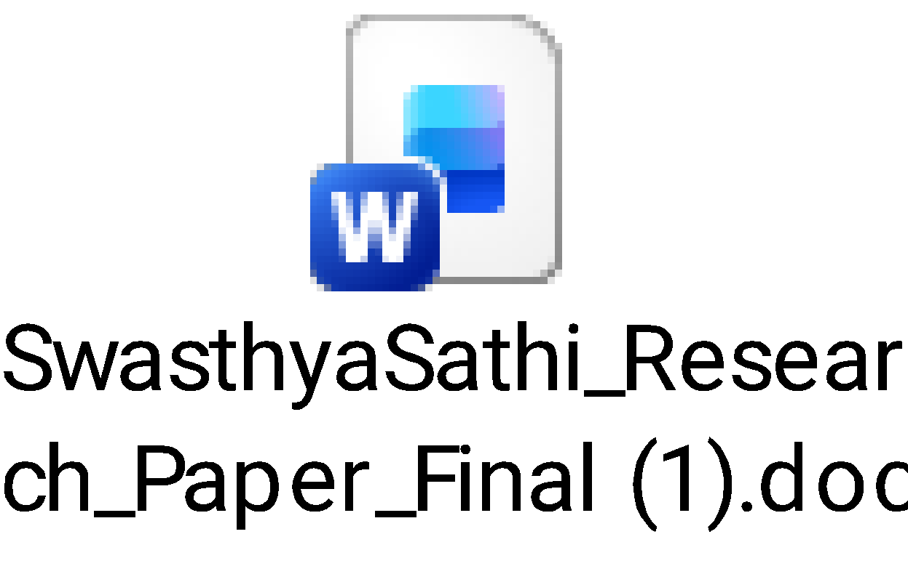

ANNEXURE B: CLINICAL VALIDATION CERTIFICATE
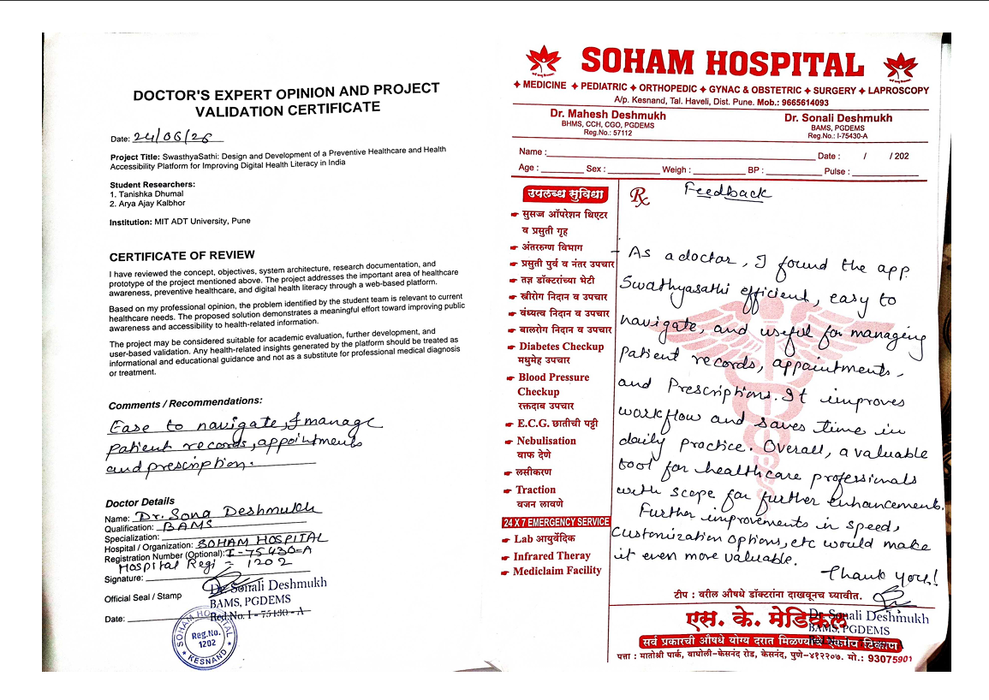

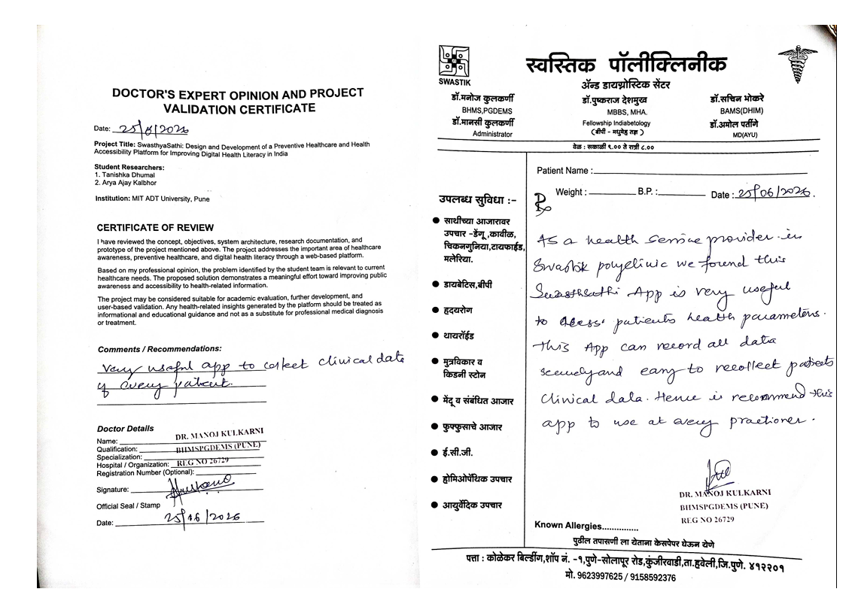

IEEE Student Branch, MIT ADT University, Pune
TechForGood 2026 | 1st June – 30th June 2026

